

**WALCHAND INSTITUTE OF TECHNOLOGY, SOLAPUR.**

**ELECTRONIC AND TELECOMMUNICATION ENGINEERING**

**YEAR 2019-2020**

Project Synopsis

1. Name of course: B.E. ( Electronics and Telecommunication Engineering)
2. Name of Students: Name Roll no. Signature

1. Shreya Shah 37

2.Madiha Shaikh 38

3. Akansha Jain 39

3. Name of guide: P D R Patnaik

4.Name of the project:

5. Whether project is sponsored: No

6. Problem Statement:

Our goal is to design and implement a hydroponic prototype which proves the effective growing hydroponics plant using mineral nutrient solution including machine learning Algorithm to optimise growth and taste of plants.

7.Scope of the Project:

The hydroponics plantation using reinforcement algorithm trains the system to observe the plants growth monitor the supply of water, supply of required amount of nutrient and make decision which are appropriate for the system. With the world’s population nearing 7.5 billion – and global prosperity and the desire for more resource-intensive foods rising steeply too – it’s clear that farming needs to become more productive. The performance of machine learning model improves as it gains experience overtime. One way of meeting food needs could be hydroponics – growing plants without soil, instead using a nutrient-rich solution to deliver water and minerals to their roots. Hydroponics develop protocols for evaluating selected cultivars of leaf, fruits and seed yielding especially vegetables herbs and spices and to determine factors effecting their adaption to sustainable hydroponics culture under controlled environment culture system. To asses the relative suitability of different mineral nutrient solution formulation for growth, development ,yield and marketable quality of selected fruits, vegetables and herbs in both aggregate and liquid-culture hydroponics system ,it develops nutrient management strategies for optimizing nutrient use efficiency of fruits, vegetables and herbs and to minimize nutrient losses through run-off from open loop hydroponics system.

8. Brief Description of the Project:

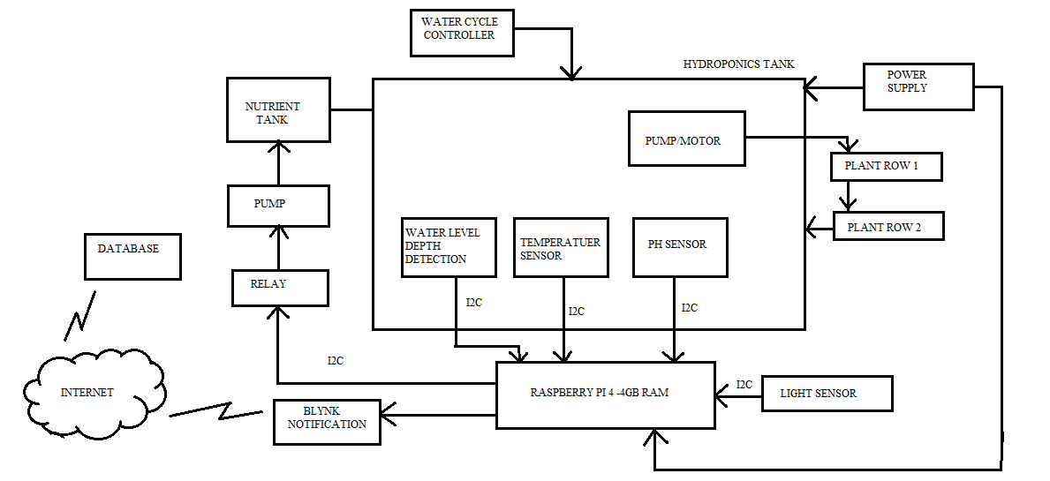

Fig. 1. HARDWAREBLOCK DIAGRAM

1. WATER LEVEL DEPTH DETECTION SENSOR:

Water level Sensor is an easy to use, cost effective high level/drop recognition sensor, which is obtained by having a series of parallel wires exposed traces measured water volume in order to determine the water level.

* Operating Voltage: DC3-5V
* Operating Current: Less than 20 mA
* Sensor type: Analog
* Detection Area: 40mm*16mm
* Operating Temperature: 10-30 degree Celsius

The water level sensor will be placed in the water tank containing plants when the amount of water is decreased then the amount of required water the user will be notified and the tank will be filled up again to the desired range. This flow of water will be controlled by pump/water cycle controller the water level sensor and pump will be connected by raspberry pi 4 and notification will be received on the blynk app of the authenticated user.

1. WATER TEMPERATUER SENSOR:

The Water Temperature Sensor is capable of measuring temperature in the range of -5 degrees centigrade to +50 degrees centigrade (23F-122F), with a resolution of 0.1degree. the temperature is measured by sensor DS18B20 which is waterproof and used to measure the temperature of liquid (nutrient solution) it is a low price and good accuracy (-0.5 to +0.5 degree centigrade) .the water temperature sensor will be checking the temperature of the water /nutrient solution and will maintain it between 65F-80F. if the temperature is increased above this limit than cooling agents are added to the water to maintain the temperature of water and nutrient solution. The cooling agent in this project is cold water which will be supplied using water pump while supplying the cold water the amount of nutrient in water is checked and adjusted accordingly.

1. PH SENSOR:

The PH sensor module was chosen based on low cost, good functionality, low physical size . the module was use to measure the output voltage of phelectrode .ThePH would control pump for adding acid to decrease the the PH to required amount .the ph range is different for different crops in general it should be between 5.5-6.5.

If a solution is alkaline then it has a PH in the range of 7.1 to 14. The ideal PH for most hydroponic gardening applications is between 5.8 and 6.2, except for rockwool cultivation,

Which likes a slightly lower PH of about 5.5. PH is important to maintain in given range because it affects availability and absorption of several of the 16 atomic elements need for plant growth .

1. LIGHT SENSOR:

As hydroponics is an indoor plantation system the amount of light given to the plants should be sufficient enough for proper growth light sensor such as LED an 75 fluorescent grow light can be used to maintain the amount of light and help in growth of plants. The mcu will need to distinguish the difference between the sunlight and the LED arrays to know to know the brightness of array.

1. NUTRIENT TANK:

The plant grown using hydroponic media provides no nutritional value, so having proper nutrition solution is vital to plant life it is crucial that the nutrient solution is monitored and fed properly to the plants. The two most important parameters of nutrient solution are pH and EC. Different plant in hydroponic require different nutrient solution concentration for growth

It is important to control nutrient solution concentration in order to provide optimal condition in root zone. This allows maximum uptake of nutrient into the rest of the plant’s cellular structure. A hydroponic nutrient needs to have Nitrogen(N), Potassium( K), Phosphorous(P).

Calcium(Ca),Magnesium (Mg), Sulphur(S), Iron(Fe), Magnese(Mn)etc.

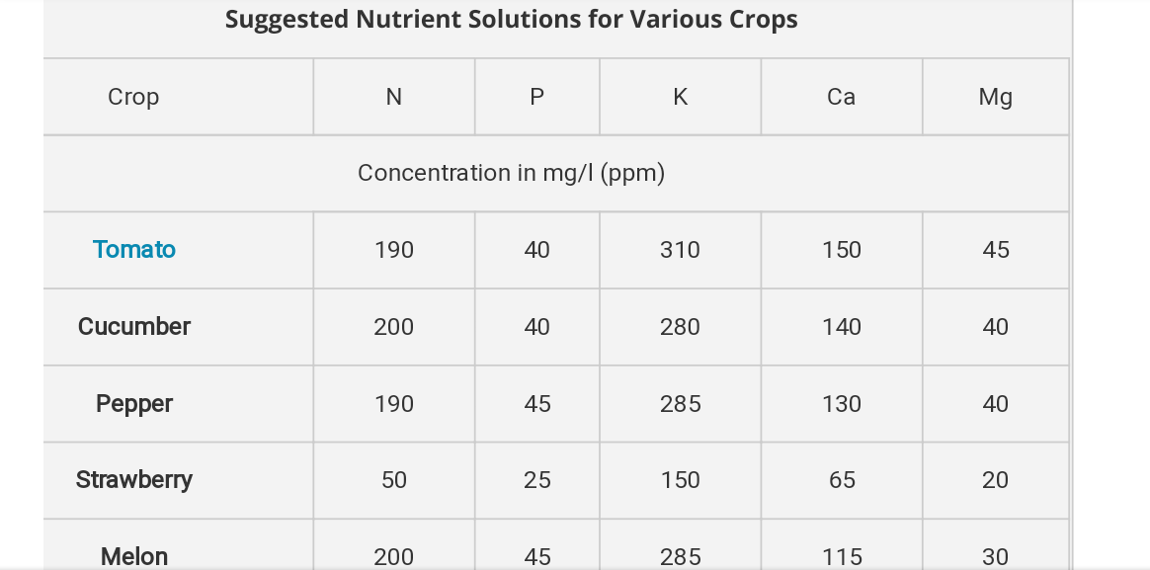

Fig.2 NUTRIENT SOLUTION FOR VARIOUS CROPS

1. PUMP/WATER CYCLE CONTROLLER:

The flow of water is controlled using the water pump when the quantity of water is reduced water is supplied using the pump. The nutrients are also supplied using the pump. on reduce pH level acids are given to the tank through the water pump, on increase in temperature the temperature is controlled by sending cold water using pump. It controls complete water requirement for hydroponic plant .

1. POWER SUPPLY:

Our system will require both a AC to DC 12 volt subsystem and will require DC to DC regulated voltage which will require 5 and 3.3 regulated low ripple DC.

1. RASPBERRY PI 4:

The Raspberry Pi 4 offers ground-breaking increases in processor speed, multimedia performance, memory, and connectivity compared to the prior-generation boards, while retaining backwards compatibility and similar power consumption. The Raspberry Pi 4 provides desktop performance comparable to entry-level x86 PC systems. The Raspberry Pi 4 comes in three on-board RAM options for even further performance benefits: 1GB, 2GB and 4GB.  
This product's key features include a high-performance 64-bit quad-core processor, dual-display output via two Micro HDMI ports, up to 4K resolution, hardware video decoding at up to 4Kp60, up to 4GB of RAM, dual-band 2.4/5.0 GHz wireless LAN, Bluetooth 5.0, Gigabit Ethernet, USB 3.0, and PoE capability.Due to the higher power requirements, the Raspberry Pi 4 requires a 3.0A USB-C supply power(sold separately). If you have an existing power supply that is rated at 3.0A, you may utilize a micro USB to USB-C adapter to utilize your existing Micro USB power supply to power the Raspberry Pi 4.  
The standard HDMI port that were part of previous generation Raspberry Pi generation boards is replaced on the Raspberry Pi 4 by two Micro HDMI ports to provide dual monitor support. A 4K60P Micro HDMI to HDMI cable is required (or two cables for dual monitor operation).  
  
**Note: Raspberry Pi 4 compatible operating system is required for operation.**

Software Architecture and Basic Algorithm:

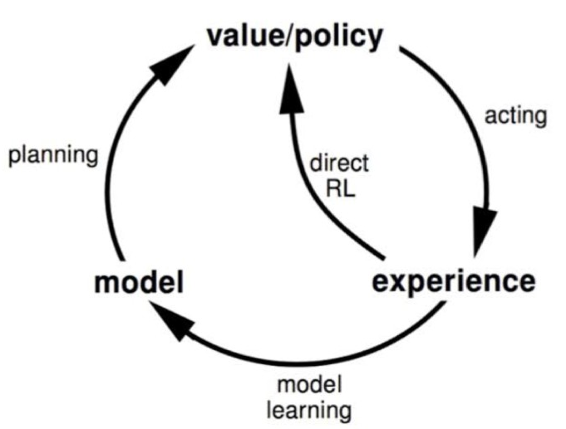

Fig 2. Reinforcement algorithm

  Using this algorithm, the machine is trained to make specific decisions. It works this way: the machine is exposed to an environment where it trains itself continually using trial and error. This machine learns from past experience and tries to capture the best possible knowledge to make accurate business decisions. Reinforcement Learning (RL) refers to a kind of Machine Learning method in which the agent receives a delayed reward in the next time step to evaluate its previous action.

In hydroponics we are using reinforcement algorithm which trains our system to observe the plants growth monitor the supply of water, supply of required amount of nutrient and make decision which are appropriate for the system the reinforcement algorithm helps our system to learn form itself and develop its techniques. Reinforcement algorithm trains itself by continuous trial and error assessment .

1. Hardware Components:

* Raspberry pi 4- 4GB RAM with adapter
* 16 GB class 10 SD card
* Water Level detection Sensor
* Temperature sensor
* pH sensor
* Light sensor
* Pump
* Hydroponics kit

1. Software Platform:

* Python
* Raspbian OS.

1. Budget: INR 8000

Name and signature Dr. Dube R.R

Project Guide Head,E&TC Department